User Guide

This software was developed for storing a list of video games, along with details such as the platform, genre, developer, price, and its rating.

The program reads and writes the data to file in Xml format.

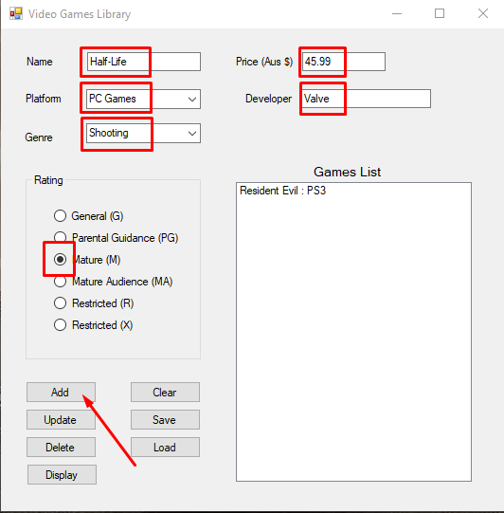

To add new games to the list, simply enter the details in the highlighted areas and click the add button.

The game entry will appear in the Game List box on the right.

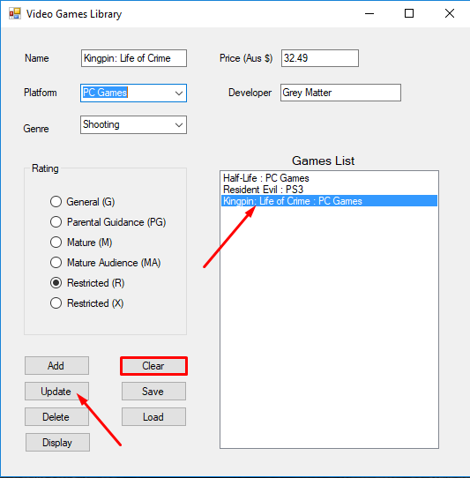To edit game entries, select a game from the games list and the details will appear in the input fields. You can then change the information and click the update button show in the picture on the right. The games information will be changed.

To clear the input fields, simply click the clear button highlighted as shown.

The display button can be used to show the details again.

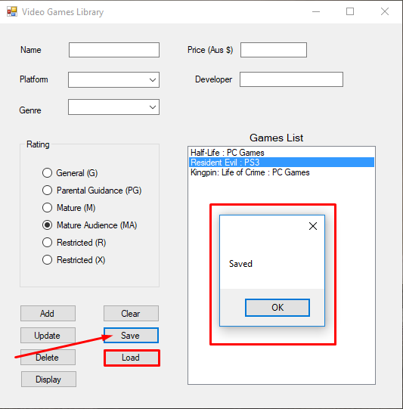

To save the list of game entries, simply click save button as shown. A dialog box will appear to let you know your save was successful.

The games list will load on start up, but at any time you can use the load button highlighted as shown to refresh your game list.

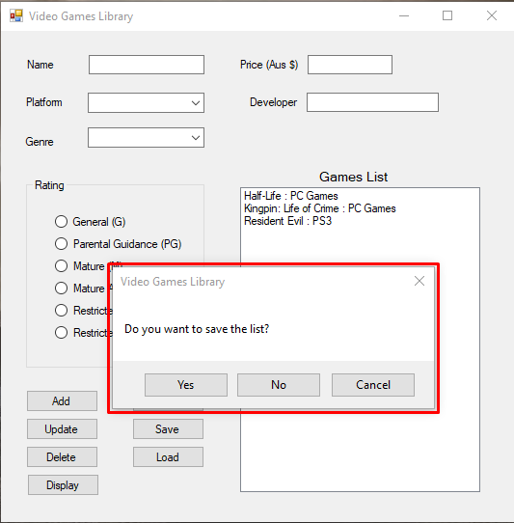Upon closing the program, you will be prompted with a dialog box with three options:

* Yes: to save your data and close
* No: to close without saving
* Cancel: to return to the running program